Logbook 3 (for offline log preparation)
Name: | Yvette Lee EnQi
Week Date: | Part A -Meeting 4 of 8
(The above information is for you to keep track of which week this log is applicable for. This information is not required in the online logbook as the system will find your name, your supervisor’s name, and take the submission date, automatically. You must submit the online log in the relevant week. Logs cannot be backdated to missed weeks.)

Meeting date:  (please note if no meeting is planned this week) | 23/07/2026
Work Undertaken this week:  (No more than 4000 characters, including spaces) | Chassis Design Refined in OpenSCAD  I converted the preliminary Tinkercad sketch into a parametric OpenSCAD model. The design now includes:  - 220 mm × 200 mm × 3 mm base plate with rounded corners and cable routing channels  - Four motor mounts with integrated encoder housings and M3 screw holes  - Adjustable camera mast (80 mm height, –15° pivot) with sun shield  - Front-mounted ultrasonic sensor brackets (bottom edge, facing forward)  - Battery tray with retention clips and strap slots  - IP54-rated outside casing shell with ventilation slots, wheel cutouts, and a removable top lid  The model was rendered with distinct colours per component for clarity. Ground clearance is confirmed at 30 mm with wheels correctly positioned at ground level (Z = 0).  Transfer Learning Pipeline Implemented  I wrote a complete PyTorch training script for MobileNetV3-Small transfer learning. The pipeline:  - Loads mobilenet_v3_small pre-trained on ImageNet from torchvision.models  - Replaces the classifier head with nn.Linear(576, 3) for healthy/stressed/diseased classes  - Stage 1: freezes feature extractor, trains classifier for 10 epochs (lr = 1e-3)  - Stage 2: unfreezes the last three inverted residual blocks, fine-tunes for 20 epochs (lr = 1e-4)  - Exports trained model to ONNX format for TensorFlow Lite conversion  - Includes data augmentation: rotation (±15°), horizontal flip, colour jitter, and Gaussian blur  The script runs successfully on CPU with dummy data validation. PlantVillage dataset download and real field image collection are scheduled once components are assembled.  ROS2 Jazzy + Gazebo Simulation Operational  Installed ros-jazzy-gazebo-ros-pkgs and ros-jazzy-turtlebot3-gazebo on WSL2. Despite the Gazebo Classic end-of-life warning, the simulation launches and runs correctly. Verified:  - turtlebot3_world.launch.py loads without errors in Gazebo Classic  - Keyboard teleoperation (turtlebot3_teleop) controls the Burger model  - Basic understanding of /cmd_vel topic and differential drive kinematics  Wiring Architecture Defined  Created a complete GPIO pinout table for the Raspberry Pi 5. All sensor and actuator connections are assigned to avoid bus conflicts:  - I2C (GPIO 2/3): MPU9250 IMU  - UART (GPIO 14/15): NEO-M8N GNSS  - PWM (GPIO 12/18): L298N motor driver speed control  - Digital GPIO: HC-SR04 triggers/echoes, wheel encoder inputs, motor direction pins  - CSI: Pi Camera Module 3  - USB 3.0: Coral TPU Accelerator  Project Outline Progress  Completed the Introduction (Project Justification), Aims & Objectives, Methodology, Resource Analysis, and Project Plan sections. The Risk Assessment Form, Ethics Checklist, and Resource Checklist (Appendices B & C) are filled and ready for supervisor signature. Remaining: final references check, Gantt Chart export for Appendix A, and proofreading before the 31 July deadline.
Problems encountered:  (No more than 4000 characters, including spaces) | - Gazebo Classic end-of-life warning: The package displays a deprecation notice on launch. This is cosmetic only — simulation functionality is unaffected. No action required unless migrating to Gazebo Ignition later.  - No real plant image dataset: The training script was verified with dummy tensors. PlantVillage dataset (54K images) must be downloaded, and field images of Singapore leafy greens must be collected before fine-tuning can begin.  - HC-SR04 voltage level: The Echo pin outputs 5V logic, but the Pi 5 GPIO is 3.3V tolerant. A voltage divider (1 kΩ + 2 kΩ resistor) or logic-level shifter is required for each ultrasonic sensor to prevent damage.  - Motor driver current unverified: The L298N datasheet claims 2A per channel, but TT motor stall current is unknown until physical motors arrive. May need to upgrade to DRV8833 or add heat sinks if the L298N overheats.
Tasks agreed for upcoming week:  (No more than 4000 characters, including spaces) | - Procure components: Submit approved Project Outline to supervisor and place orders for motors, motor drivers, ultrasonic sensors, GNSS module, IMU, and LiPo battery.  - 3D print test motor mount: Validate PETG print settings, hole spacing, and motor fit before printing the full chassis.  - Collect plant images: Download PlantVillage dataset and try to photograph 50+ images of local crop plants (healthy and stressed) for initial dataset building.  - Complete Fritzing wiring diagram: Build the breadboard layout in Fritzing using the pinout table, including voltage dividers for ultrasonic echo pins.  - Breadboard prototype: Wire Pi 5, one motor driver, one ultrasonic sensor, and IMU on a breadboard to verify I2C and GPIO logic before soldering.  - Do not solder any connections until the breadboard prototype is verified and supervisor reviews the wiring diagram.
Figures:  (Upload image files in the online Log Form, but feel free to keep notes here about which images you intend to upload. Use “Figure Caption” information as the filenames, e.g., “Figure 1 – A screenshot of the initial constrained Sketch in CATIA.jpg”) | 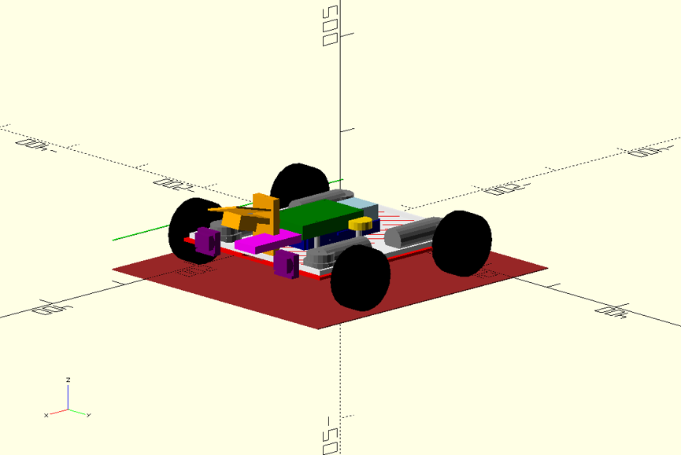  Figure 1 — OpenSCAD chassis model with IP54 enclosure shell (cutaway view)  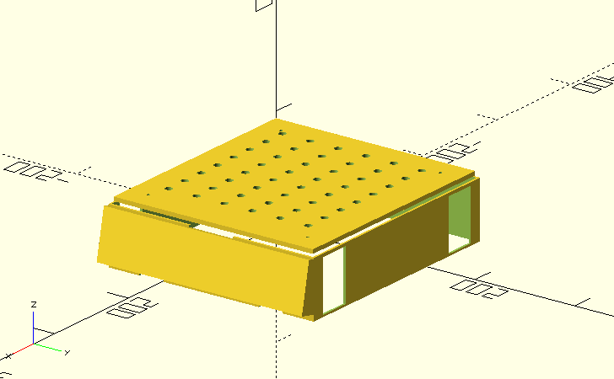  Figure 2 — OpenSCAD outside casing only (product exterior)  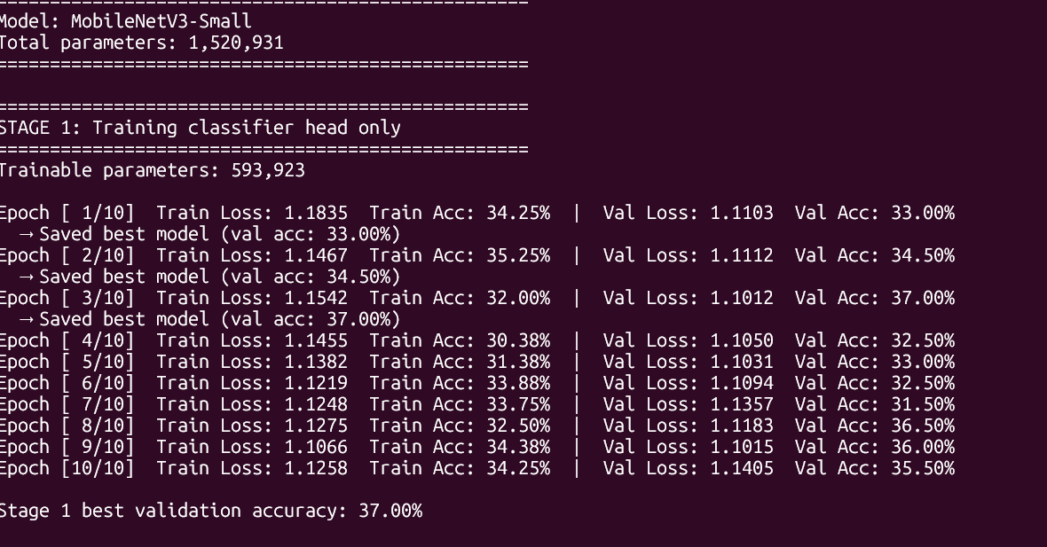  Figure 3 — MobileNetV3 training script execution  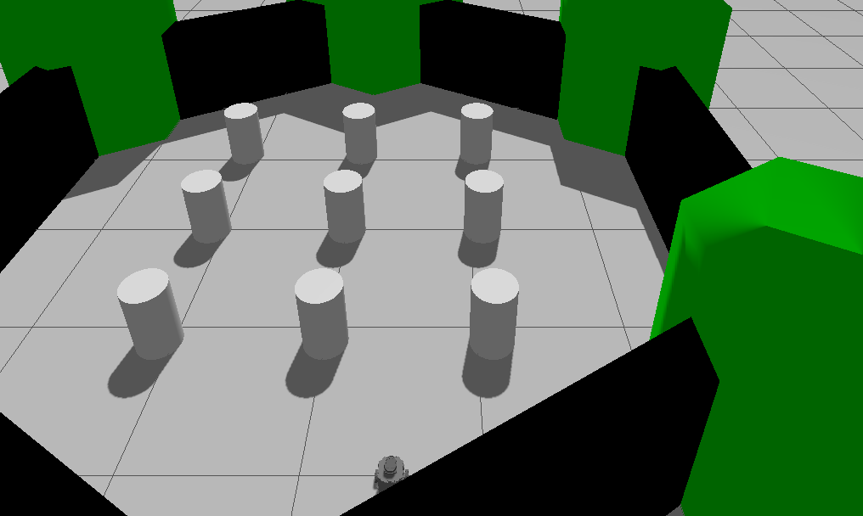  Figure 4 — TurtleBot3 Gazebo simulation  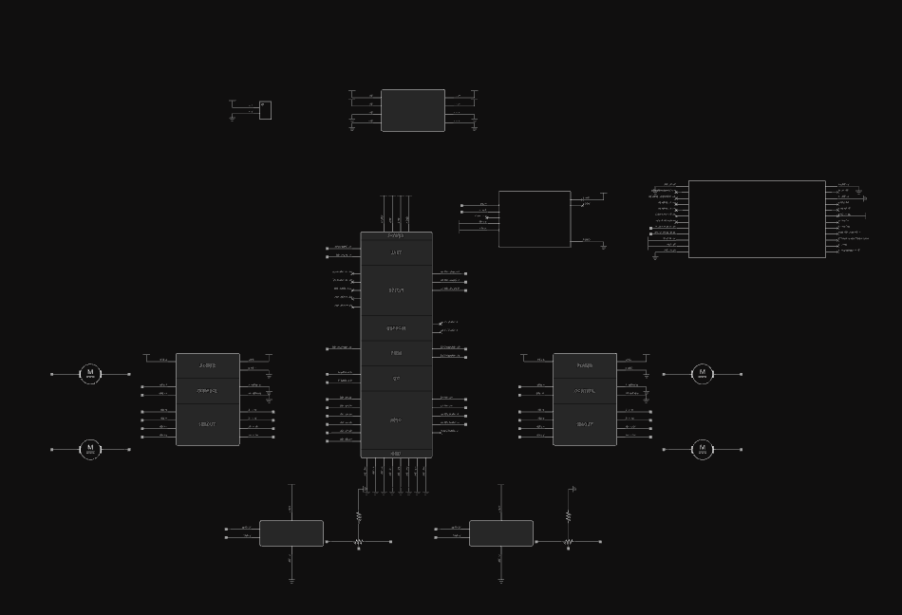  Figure 5 — GPIO pinout table for wiring diagram
  Component | Signal | Pi 5 Pin # | GPIO # | Type | Notes
  L298N #1 | ENA (PWM) | 32 | GPIO 12 | PWM0 | Left motor speed
  (Left Motors) | IN1 | 36 | GPIO 16 | Output | Left direction
   | IN2 | 38 | GPIO 20 | Output | Left direction
   | GND | 34 | — | GND | Common ground
   | 12V | 2 | — | 5V | From buck or battery*
  L298N #2 | ENA (PWM) | 12 | GPIO 18 | PWM0 | Right motor speed
  (Right Motors) | IN1 | 22 | GPIO 25 | Output | Right direction
   | IN2 | 37 | GPIO 26 | Output | Right direction
   | GND | 39 | — | GND | Common ground
   | 12V | 4 | — | 5V | From buck or battery*
  Encoder FL | Phase A | 29 | GPIO 5 | Input | 20 PPR, pull-up 10kΩ
  Encoder FR | Phase A | 31 | GPIO 6 | Input | 20 PPR, pull-up 10kΩ
  Encoder RL | Phase A | 33 | GPIO 13 | Input | 20 PPR, pull-up 10kΩ
  Encoder RR | Phase A | 35 | GPIO 19 | Input | 20 PPR, pull-up 10kΩ
  HC-SR04 L | VCC | 2 | — | 5V | Power
   | Trig | 16 | GPIO 23 | Output | 10 µs pulse
   | Echo | 18 | GPIO 24 | Input | Via voltage divider
   | GND | 14 | — | GND
  HC-SR04 R | VCC | 4 | — | 5V | Power
   | Trig | 11 | GPIO 17 | Output | 10 µs pulse
   | Echo | 13 | GPIO 27 | Input | Via voltage divider
   | GND | 9 | — | GND
  MPU9250 IMU | VCC | 1 | — | 3.3V | Power
   | SDA | 3 | GPIO 2 | I2C | Address 0x68
   | SCL | 5 | GPIO 3 | I2C | Address 0x68
   | GND | 6 | — | GND
  NEO-M8N GNSS | VCC | 17 | — | 3.3V | Power
   | TX → Pi RX | 10 | GPIO 15 | UART RX | /dev/ttyAMA0
   | RX ← Pi TX | 8 | GPIO 14 | UART TX | /dev/ttyAMA0
   | GND | 25 | — | GND
  Pi Camera V3 | CSI | CSI port | — | MIPI | Ribbon cable, no GPIO
  Coral TPU | USB | Any USB 3 | — | USB 3.0 | No GPIO needed

